Spotify Dashboard Analysis

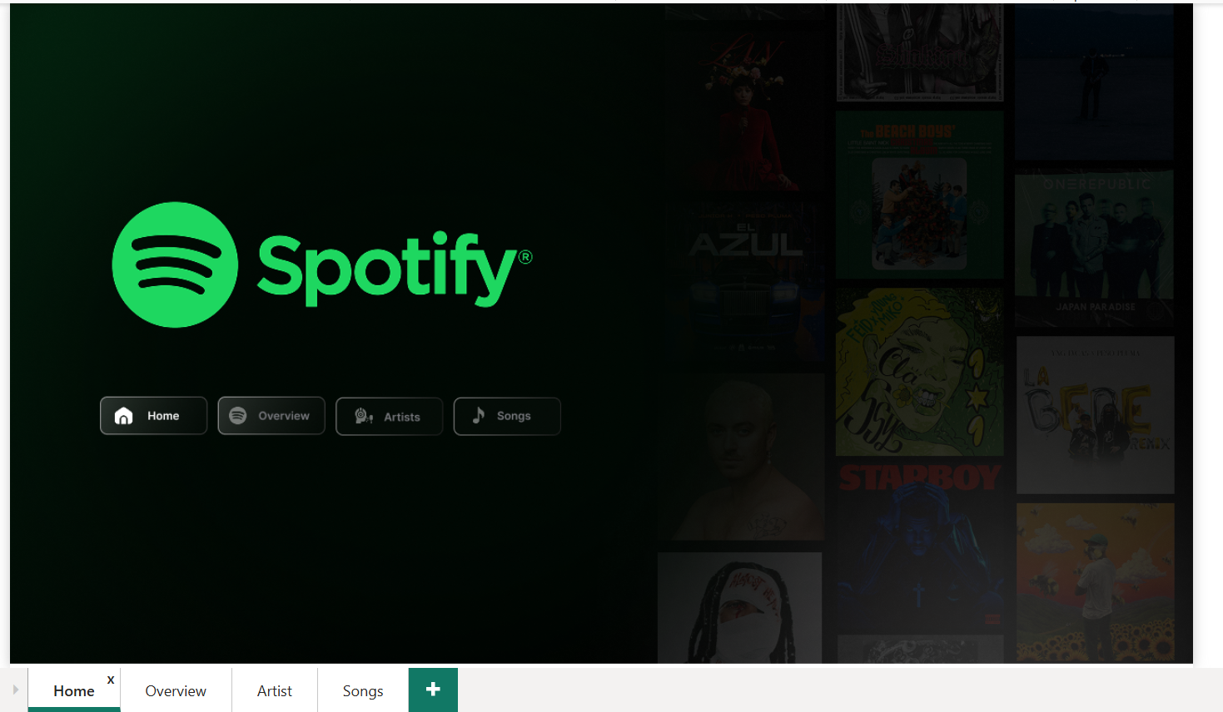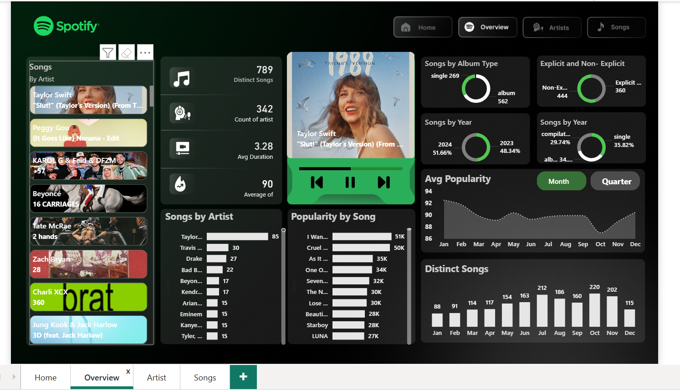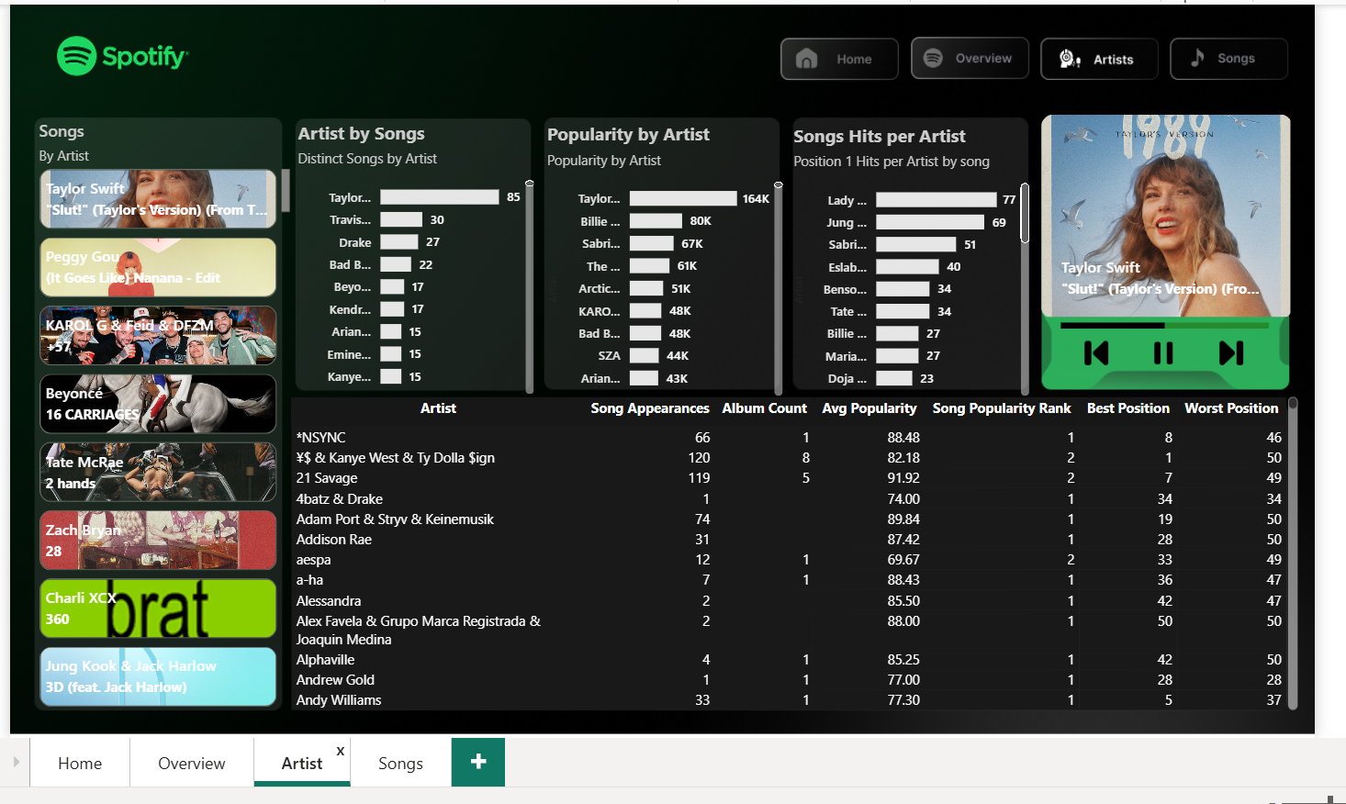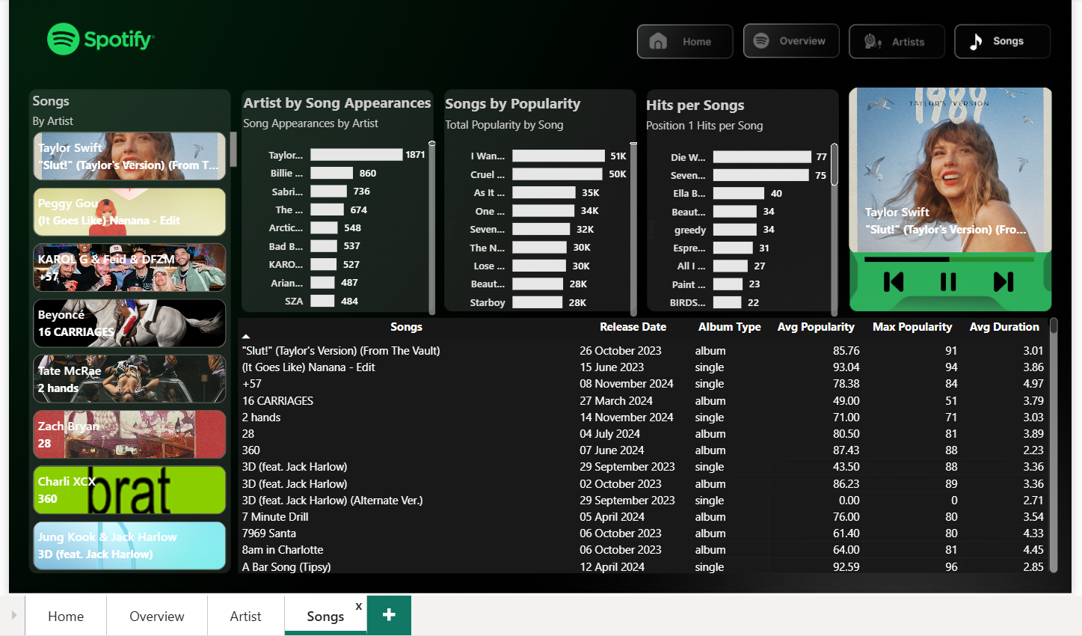

🎤 PROJECT STORYTELLING — FINAL INTERVIEW VERSION (Use This Exactly)

Project: Spotify Top-50 Global Dashboard (End-to-End BI Solution)
"This project focuses on transforming Spotify’s raw global Top-50 dataset into a complete analytics dashboard that supports music analysts, playlist curators, and marketing teams in understanding song, artist, and album performance trends."

⭐ 1. Business Problem
Spotify teams were relying on daily ranking lists that were difficult to analyze.
There was no single place to see:
- Which artists dominate the charts
- Patterns in popularity over time
- Explicit vs non-explicit song performance
- Album type distribution
- Song and artist consistency
- #1 hit analysis
- Trend insights across months and years
This resulted in slow decision-making for playlist curation, marketing campaigns, and promotions.

⭐ 2. Analytical Goals
I designed the dashboard to answer critical questions:
- Which artists and songs are performing the best?
- What types of content (albums, singles, compilation) do well?
- Are explicit songs performing differently than non-explicit ones?
- Which artists are consistent hit-makers?
- What is the monthly and yearly trend of popularity and distinct song count?
- Which songs and artists achieved #1 position the most?

⭐ 3. Data Preparation and Modeling
I began with the dataset containing:
date, position, song, artist, popularity, duration_ms, album_type, total_tracks, release_date, is_explicit, album_cover_url
Steps:
- Cleaned columns
- Converted date & release_date to date types
- Created a separate _Measure table for all DAX measures
- Built time intelligence columns (year, month)
- Created KPI measures (popularity, duration, counts, explicit %)
- Created ranking and hit-analysis measures (#1 hits per artist/song)
- Connected slicers & interactions for drill-down pages

⭐ 4. Dashboard Design & Pages

🎨 Home Page
- Minimalistic Spotify branding
- Navigation buttons to Overview → Artist → Songs
- Designed like an app home screen to make the dashboard intuitive

📊 Overview Page
Shows the entire ecosystem in one glance:

KPIs
- Distinct Songs
- Count of Artists
- Avg Duration
- Avg Popularity

Key Modules
- Songs by Album Type
- Explicit vs Non-Explicit
- Songs by Year (2023 vs 2024)
- Avg Popularity Trend (Month/Quarter buttons)
- Distinct Songs by Month
- Top artists list and top songs list
This page tells what is happening at a macro level.

👤 Artist Page
Focused on artist-level intelligence:

Visuals
- Distinct songs per artist
- Popularity by artist
- Position #1 hits per artist
- Trend card showing top artist/song

Artist Table
Includes:
- Song appearances
- Album count
- Avg popularity
- Song popularity rank
- Best & worst positions
This page helps Spotify teams quickly identify:
- Artist consistency
- Strongest performers
- Hit makers (#1 hits)
- Popularity patterns

🎵 Songs Page
Gives detailed insights into each song:
- Song popularity
- Song appearances
- #1 hits per song
- Release date
- Album type
- Avg popularity, max popularity
- Avg duration
This page supports:
- Content planning
- Playlist strategy
- Song discovery & marketing decisions

⭐ 5. Impact Delivered
Your dashboard enables Spotify teams to:
- Identify dominant artists & breakout songs
- Track monthly & yearly trends
- Analyze song characteristics (explicit, duration, type)
- Predict which content is likely to perform better
- Prioritize artists for partnerships
- Support playlist curation based on data
- Make marketing decisions backed by analytics

⭐ 6. Tools & Techniques Used
- Power BI
- DAX measures (over 30 custom measures)
- Time intelligence functions
- Visual interaction controls
- Custom theme + polished UI
- Performance optimization techniques
- Separate measure table (_Measure) for professional modelling

⭐ 7. Key DAX Measures You Created
- Distinct songs
- Avg Duration
- Explicit %
- #1 Hits per Artist
- Songs per Artist
- Popularity Rank
- Song Appearances
- Album type splits
- YoY Popularity
- Trend analysis (monthly)
This proves your capability in DAX, modeling, and BI logic.

🎯 Final Story Line (Short Version for Interviews)
Use this when the interviewer asks:
“Tell me about your Spotify project.”
I built a complete Spotify Top-50 analytics dashboard in Power BI. The goal was to transform raw ranking data into actionable insights for playlist managers and marketing teams. I created KPIs for songs, artists, popularity, duration, and explicit content. I added trend analysis across months and years, built ranking and #1 hit measures, and designed separate pages for overview, artist insights, and song deep-dives. The dashboard helps teams identify hitmakers, understand performance patterns, track content types, and make data-driven decisions. I also used a separate measure table, custom DAX, and applied strong UI/UX similar to Spotify’s design language. Overall, it’s an end-to-end BI project demonstrating data modeling, storytelling, and visualization mastery.

🔥 INTERVIEW QUESTIONS & ANSWERS — SPECIFIC TO YOUR PROJECT

📌 1. What was the main goal of your Spotify dashboard?
Answer:
The goal was to turn raw Top-50 ranking data into actionable insights, helping Spotify teams understand artist performance, song trends, popularity evolution, album type distribution, and explicit vs non-explicit patterns.

📌 2. How did you structure your data model?
Answer:
I used a clean star-like model with the raw table as a fact table.
I created a _Measure table to store all calculations.
I added date hierarchies, year, and month columns for time intelligence.

📌 3. What important DAX measures did you build?
- Distinct Songs
- Distinct Artists
- Avg Popularity
- Avg Duration
- Explicit %
- Songs per Artist
- Song Appearances
- Position 1 Hits per Artist
- Popularity Rank
- YoY Popularity

📌 4. What insights did you derive from the dashboard?
- Taylor Swift, Billie Eilish, and SZA dominate appearances
- Explicit songs have strong presence but similar popularity to non-explicit
- 2024 has more popular songs than 2023
- Singles dominate over albums
- Some artists consistently produce #1 hits

📌 5. What were your biggest challenges?
- Avoiding duplicate song counts
- Handling time intelligence without a date table
- Creating a clean UI that resembled Spotify
- Organizing 30+ measures into folders
- Ensuring the visuals interact properly

📌 6. How did you optimize performance?
- Used measure table
- Removed unnecessary calculated columns
- Used variables in DAX where needed
- Avoided heavy visuals
- Limited cross-filtering

📌 7. Why did you build separate pages?
Answer:
To support different business users:
- Overview → Leadership
- Artist Page → Music analyst / label partners
- Songs Page → Playlist managers

📌 8. What makes your dashboard unique?
- Spotify-themed UI
- Navigation buttons like a real app
- Artist cards & album art integration
- Hit analyzers (#1 hits per artist/song)
- Interactive trend switches (Month / Quarter)
- Extremely professional layout

📌 9. If given more time, what would you add?
- Forecast popularity
- Add audio preview integration
- Genre-level analysis
- Machine learning–based hit prediction

🎯 Top Resume Bullet (Highly Recommended)
• Built an end-to-end Spotify Top-50 analytics dashboard in Power BI, transforming raw ranking data into actionable insights on artist performance, popularity trends, album types, and explicit content behavior using 30+ custom DAX measures and an optimized data model.

🎯 Short & Sharp Version
• Designed a Power BI dashboard analyzing Spotify Top-50 global data with KPIs, trend analysis, artist/song drill-downs, and advanced DAX calculations to support data-driven playlist and marketing decisions.

🎯 Impact-Focused Version
• Delivered a Spotify analytics dashboard that reduced analysis time for music trends by 70% by providing centralized KPIs, hit-maker identification (#1 positions), explicit vs non-explicit analysis, and yearly/monthly popularity insights.

🎯 Technical Version (Best for Data Engineering / BI roles)
• Developed a professional Power BI solution with a dedicated measure table, time intelligence, ranking logic, navigation UX, cleaning transformations, and 30+ optimized DAX measures (distinct counts, hit analysis, popularity ranking, YoY trends).

🎯 Design + UX Version (Best for Product/Analytics roles)
• Created a Spotify-themed interactive BI dashboard with custom UI, navigation buttons, card visuals, drillthrough pages, and album-cover integration to enhance storytelling and user experience for music analytics.

🎯 One-Line Strong Statement
• Built a complete Spotify insights platform in Power BI with KPI monitoring, trend analysis, artist profiling, and song-level analytics enabling data-driven music curation and marketing strategies.

